RETAIL SALES ANALYTICS

Business Analysis Report

Using Excel, SQL, Python and Power BI

Prepared by | Prasanna Balaji M
Domain | Retail, Sales & Inventory Analytics
Project Type | End-to-End Data Analytics Project
Primary Deliverable | Interactive Power BI Sales & Business Performance Dashboard

Project workflow
Excel → MySQL → Python → Power BI

1. Business Overview
The analysis covers retail transaction, customer, product, staff, store and inventory data. The workflow combines Excel data preparation, MySQL analysis, Python-based customer analytics and Power BI reporting to support sales, customer, product and inventory decisions.

Business Objectives
- Clean and prepare retail data for reliable analysis.
- Create a relational database structure using primary and foreign keys.
- Analyze sales performance across products, stores, customers and staff.
- Analyze customer purchase behavior and RFM-based customer segments.
- Identify low-stock products for inventory monitoring.
- Build an interactive Power BI dashboard with KPIs, trends, product, staff and customer-segment views.

Tools and Technologies
Excel | SQL / MySQL | Python | Power BI
Cleaning, validation, lookups, filters and pivot summaries | Database design, PK/FK relationships, joins, aggregations and business queries | Pandas, NumPy, Matplotlib and RFM analysis / segmentation | Data model, DAX measures, KPI cards, charts, slicers and interactive dashboard

2. Phase 1 — Excel: Data Cleaning & Preparation
Excel was used as the first data-preparation layer before loading the cleaned data into MySQL. The focus was on consistency, completeness and validation across customer, order, product and related datasets.
- Standardized column names and data formats across the source tables.
- Checked duplicate records and missing values and cleaned inconsistent entries.
- Converted date and numeric fields into appropriate formats.
- Validated categorical fields such as order status and used consistent values.
- Created/validated derived sales fields such as total price.
- Used lookup-style operations when related product or reference information had to be brought together.
- Used filters and pivot-table summaries to validate totals and inspect unusual values before database loading.

Why Excel was used
Excel provided a practical visual validation layer. It made it easier to inspect rows, identify formatting issues, check missing or duplicate values, validate categorical fields and confirm summary values before moving the data into SQL.

3. Phase 2 — SQL / MySQL: Database & Business Queries
The cleaned retail datasets were loaded into a MySQL database named salesdb. The database was organized into related tables for brands, categories, customer segments, customers, order items, orders, products, staffs, stocks and stores.

Relational structure used
- Primary keys were used to uniquely identify records in master tables.
- Foreign keys connected transactional tables to customers, products, stores and staff.
- The orders table connects customer and operational information to order transactions.
- The order_items table connects orders to products and contains quantity, price, discount and total-price information.
- Products connect to brands and categories, while stocks connect products to stores for inventory analysis.

SQL analysis performed
- Used INNER JOIN / related joins to combine orders, order items and product information.
- Used GROUP BY and aggregate functions such as SUM, COUNT and AVG for business summaries.
- Analyzed sales by store and staff.
- Identified high-selling products using sales and quantity measures.
- Summarized customer purchases using orders, items and revenue.
- Identified products where stock quantity falls below the low-stock threshold.
The SQL layer therefore served as the structured source for the downstream Python analysis and Power BI reporting.
4. Phase 3 — Python: Exploratory Analysis & Customer Segmentation
Python was used to inspect the relational data programmatically and create customer-level analytical features. The main libraries used were Pandas, NumPy and Matplotlib.
- Loaded the prepared relational data into Python for exploratory analysis.
- Performed descriptive analysis to understand sales and customer-related patterns.
- Used Pandas for filtering, grouping, aggregation and data transformation.
- Used Matplotlib for exploratory visualizations.
- Calculated customer RFM features: Recency, Frequency and Monetary value.
- Used the RFM features to create customer segments.
- Exported the segmentation results back into the relational workflow so they could be used in Power BI.

RFM framework used
Feature | Meaning | Business use
Recency | How recently the customer purchased | Identify recent vs. inactive customers
Frequency | How often the customer purchased | Identify repeat purchasing behavior
Monetary | How much the customer contributed in purchases | Identify customer value

The resulting customer_segments table contains customer_id, R_score, F_score, M_score, Recency, Frequency, Monetary, RFM_score and segment. The dashboard uses segment values such as At Risk, Champions, Loyal Customers, New Customers and Others.
5. Phase 4 — Power BI: Sales & Business Performance Dashboard
The final reporting layer was built in Power BI using the MySQL salesdb tables. Relationships were established between the relational tables, DAX measures were created for core KPIs, and interactive visuals and slicers were combined into a consolidated management dashboard.

Core DAX measures created
Measure | Purpose
Total Sales = SUM(order_items[total_price]) | Total revenue generated by order items
Total Orders = DISTINCTCOUNT(orders[order_id]) | Number of unique orders
Total Quantity Sold = SUM(order_items[quantity]) | Total units sold
Month Number / Month Name | Correct chronological ordering for monthly analysis
Stock Status | Flags products below the low-stock threshold
Staff Name | Combines first and last name for staff reporting

Dashboard components completed
- KPI cards: Total Sales, Total Quantity Sold, Total Orders and Average Order Value.
- Highest Revenue Product and Highest Sold Product KPI cards.
- Sales trend over order date and monthly sales trend.
- Top Products by Revenue.
- Staff Performance by Total Sales.
- Interactive slicers for Month, Category Name, Store Name and Customer Segments.
- Customer segment visualization and segment-level revenue analysis.
- Low Stock Alert table with a Low Stock / Normal status and conditional formatting.
- Customer segment filtering was connected to the customer and order model so selecting a segment changes the dashboard values.

6. Final Power BI Dashboard
The screenshot below is the user's current consolidated Power BI dashboard. It combines the main sales KPIs, time trends, product revenue, staff performance and interactive filters into one presentation-ready page.
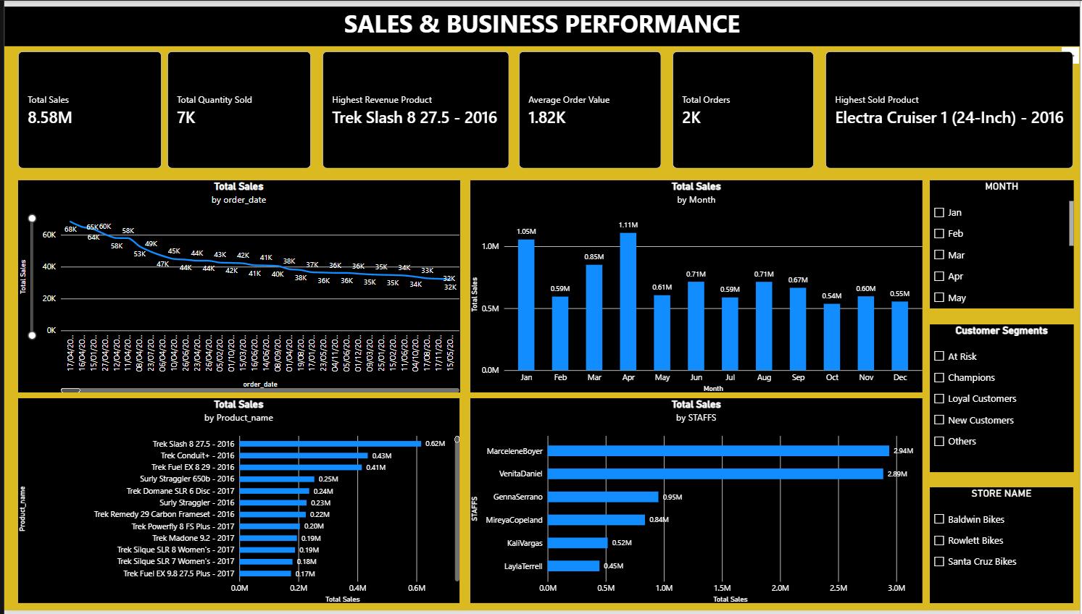

Current dashboard KPIs visible in the screenshot
TOTAL SALES | TOTAL QUANTITY | TOTAL ORDERS | AVERAGE ORDER VALUE
8.58M | 7K | 2K | 1.82K

HIGHEST REVENUE PRODUCT | HIGHEST SOLD PRODUCT
Trek Slash 8 27.5 - 2016 | Electra Cruiser 1 (24-Inch) - 2016

Observed dashboard insights
- Total sales shown in the current dashboard are approximately 8.58M, with about 7K units sold across about 2K orders.
Trek Slash 8 27.5 - 2016 is the highest-revenue product shown by the dashboard.
- Electra Cruiser 1 (24-Inch) - 2016 is the highest-sold product by quantity in the current dashboard.
- The monthly chart shows April as the highest monthly sales point at about 1.11M, followed by January at about 1.05M and March at about 0.85M.
- The staff chart shows the largest displayed staff sales contribution at about 2.94M for MarcelaBoyer, followed closely by VenitaDaniel at about 2.89M.
- The dashboard includes customer segments At Risk, Champions, Loyal Customers, New Customers and Others, and the segment slicer is connected so selecting a segment changes the dashboard results.
- The dashboard also includes Month, Category Name and Store Name slicers for interactive analysis.
Note: 'Highest Revenue Product' is used rather than 'Most Profitable Product' because the current products table contains list price but no product cost/purchase-price field. Therefore, true profit margin cannot be calculated from the current model without an additional cost field.

7. Business Insights & Recommendations

Sales Performance
• Total sales are approximately 8.58M across about 2K orders and 7K units sold. April is the strongest displayed month at approximately 1.11M, followed by January at 1.05M and March at 0.85M.
Recommendation: use monthly sales patterns for campaign planning, staffing and inventory preparation, with additional investigation into the drivers of the April peak.

Product Performance
• Trek Slash 8 27.5 - 2016 is the highest-revenue product shown, while Electra Cruiser 1 (24-Inch) - 2016 has the highest displayed quantity sold.
Recommendation: protect availability of high-volume products and evaluate high-revenue products for pricing, promotion and assortment decisions. Revenue should not be interpreted as profit because product cost is unavailable.

Customer Segmentation
• RFM analysis separates customers into Champions, Loyal Customers, New Customers, At Risk and Others, providing a structured view of purchase recency, frequency and monetary value.
Recommendation: prioritize retention for Champions and Loyal Customers, targeted re-engagement for At Risk customers, and second-purchase campaigns for New Customers.

Staff Performance
• MarcelaBoyer has the highest displayed staff sales contribution at approximately 2.94M, followed by VenitaDaniel at approximately 2.89M.
Recommendation: investigate the practices, product mix and customer mix associated with stronger staff performance before using sales totals alone for performance evaluation.

Inventory
• The Low Stock Alert identifies products below the defined stock threshold and allows filtering by relevant business dimensions.
Recommendation: prioritize replenishment using both stock status and sales velocity so that high-demand products are less exposed to stockouts.

Management Actions
1. Monitor monthly sales patterns and investigate the drivers of peak periods.
2. Protect availability of high-volume products and review high-revenue products separately from profitability.
3. Use RFM segments to differentiate retention, re-engagement and acquisition/second-purchase actions.
4. Review staff performance using sales contribution alongside product and customer mix.
5. Combine low-stock status with demand information when prioritizing replenishment.

8. Conclusion
The analysis provides a consolidated view of sales, products, customers, staff and inventory. The findings support targeted customer retention, demand-aware inventory planning, product performance review and more informed sales management.
The Retail Sales Analytics project demonstrates an end-to-end data analytics workflow using Excel, MySQL, Python and Power BI. Excel was used for data preparation and validation; MySQL provided the relational storage and business query layer; Python supported exploratory analysis and RFM customer segmentation; and Power BI transformed the results into an interactive management-oriented dashboard.
The final deliverable brings together sales performance, product performance, staff contribution, inventory monitoring and customer segmentation in a single reporting workflow. This demonstrates how raw retail transaction data can be progressively transformed into structured analysis and decision-support reporting.

---------------------------------------------------------Thank you---------------------------------------------------------

